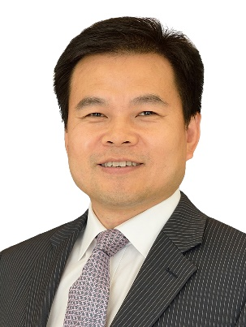
GUAN FENG
Partner, Chief Compliance Officer, Shanghai
Email: guanfeng@cn.kwm.com
Tel: +86 21 24126025
Fax: +86 21 24126150
Office: Shanghai

Areas of practice
Mr. Guan Feng's main area of practice is cross-border litigation and arbitration, especially cases pertaining to finance, asset management, equity, insurance, product liability and commercial contracts.
Mr. Guan has extensive practical and research experience in the area of banking, asset management and derivatives products dispute resolution. In addition to traditional loan and collateral enforcement, he regularly represents foreign banks and multinational companies in handling cases in connection with financial derivatives products, futures and stock option transactions and suspension of payment under letters of credit and independent guarantees based on fraud exception in the area of international trading. Moreover, Mr. Guan has been retained by financial institutions including banks, securities companies, trust companies, fund companies, futures companies, etc. to deal with numerous asset management disputes which cover the protection and recourse of investment, the legal effect of the structured asset management products and the boundary of rights and obligations of the parties involved in asset management activities, including being trustee and custodian of a product.
Mr. Guan has acted on behalf of company clients to deal with a number of equity dispute cases, including ascertainment of the legal effect of equity transfer, the triggers of a buy-back clause and disputes arisen from the fiduciary duties, etc.
In the area of insurance and product liability, he has advised numerous well-known international insurance companies on complex legal matters, including the validity of insurance policies, insurance claim settlement negotiations, legal opinions on insurance disputes, and reinsurance. He has participated in much large-scale litigation, some of which have had implications for insurance law and business practices.
Work experience
Feng Guan joined King & Wood Mallesons' Shanghai office in 2001 and is a partner of the firm.
Mr. Guan graduated from Northwestern University Law School with a LL.M. He attained his LL.B. from Fudan University Law School and a B.A. from Central Southern University of Foreign Languages and Trade. He was qualified as a PRC lawyer in 1996 and passed the New York State Bar in 2003. He is a registered PRC lawyer and New York State attorney.
Mr. Guan Feng is an arbitrator of the China International Economic and Trade Arbitration Commission (CIETAC) (finance), Shanghai International Economic and Trade Arbitration Commission (SHIAC) (finance), Shanghai Arbitration Commission (SAC) (finance), Hangzhou Arbitration Commission (HAC) (finance), and a mediator of the Jiangsu International Commercial Legal Service Center.

