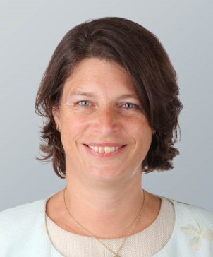

Emma Dwyer
Partner - London
Contact
Tel +44 20 3088 3754
Mob +44 7767 674 269
emma.dwyer@allenovery.com
Emma is a partner in Allen & Overy’s derivatives and structured finance team in London, a member of The Markets Innovation Group and advises on a broad range of issues relating to derivatives and structured finance transactions.
Emma has been heavily involved in the evolving market infrastructure built to address the OTC derivatives regulation, including in connection with clearing, uncleared margin and reporting. Emma has worked closely with industry bodies including with ISDA, FIA Europe and SiFMA AMG) on numerous OTC derivatives regulatory initiatives. Advisory work in recent years has also included regulatory capital treatment of cleared trades and IBOR transition and the impact on the derivatives markets and participants’ regulatory obligations.
Emma advises a wide cross section of market participants, (including sellside and buyside), market infrastructure providers (including CCPs and trade repositories) and trade associations on all aspects of derivatives regulatory implementation, documentation and advocacy and engages with regulators (in the US, Europe and the UK) in doing so.
As a key market educator, Emma continues to speak at many industry events for ISDA and others around the world on EMIR, Brexit and IBOR.
Experience highlights include:
- The LCH group on a wide range of strategic matters including most recently in relation to the introduction of settled to market mechanics and IBOR transition.
Career history
- Partner, Allen & Overy LLP, London - 2012-present
- Associate, Allen & Overy LLP, London - 1998-2012
- Trainee, Allen & Overy LLP, London - 1996-1998
Legal qualifications
- Admitted as solicitor, England and Wales, 1998
Academic qualifications
- BA Law, Fitzwilliam College, Cambridge University, 1994
Speaking engagements
- Guest Speaker at BNP Paribas, Luxembourg – EMIR 360: Everything you need to know – September 2019
- Guest Speaker at ISDA: Understanding Variation Margin Regulations and the 2016 ISDA Variation Margin Credit, September 2019
- Guest Speaker at VOB Service Symposium, Germany - ISDA Update on Derivatives Market, November 2019
Languages
- English, (Level 1 - Fluent/Bilingual)
- French, (Level 4 - Can participate in business meetings/review simple documents)

