Janet Thomas

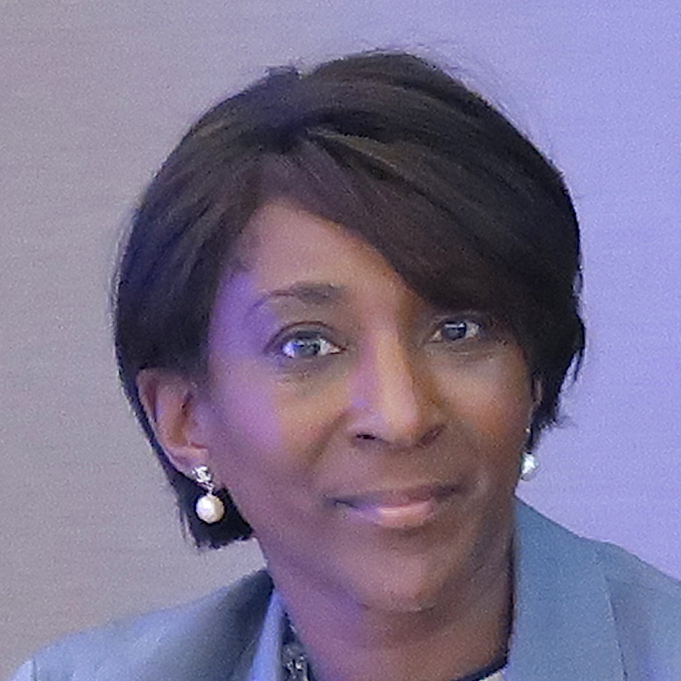

Introduction

Janet Thomas has 25 years international banking experience. She has been instrumental in transforming market structures and businesses. Janet created one of the first to market fintech FX price transparency offering on her industry knowledge at Bank of America and Citigroup where she led Citi to command the largest share of the daily $5.3 trillion FX market.

Janet Thomas bio

Janet Thomas has over 25 years of international banking and technology experience. During this time, she has been instrumental in transforming market structures and businesses, both re-framing existing and building brand new models. She has created and deployed enterprise-wide and bespoke financial technologies platforms and applications to deliver highly competitive and widely known global businesses.

Prior to her appointment as CEO of Intellect Design’s Risk, Treasury and Capital Markets business in 2018, Janet was the Founder and CEO of TouchFX, one of the first monitoring and price transparency surveillance offering for the FX industry, building on her domain knowledge as Head of EMEA Prime FX Sales at Bank of America Merrill Lynch (BAML) covering significant buy-side financial institutions.

Before her tenure at BAML, Janet was Head of Product and Marketing at Citigroup Global FX Prime Brokerage where she led Citigroup to own the largest FX Prime Brokerage business globally, commanding the largest share of the daily $5.3 trillion FX market. From developing innovative big data analytics, she identified industry trends and emerging market opportunities to create market leading technology products and platforms.

Between 2014 and 2017, Janet was President of Women in Banking and Finance (WBIF), one of the largest and most influential networking organisations across the global finance industry. During this time Janet established several international and national partnerships for e.g. with the Milken Institute and the Prime Minister, Rt. Hon. David Cameron supporting programmes that place accomplished women from Banking and Finance onto the boards of academies and schools across the UK.

Janet has remained on the Powerlist Top 100 – listing the most influential Afro – Caribbean individuals in the UK since 2014, and in 2017 was one of the 100 Women to Watch list of Cranfield University & KPMG.

